**“Covid-19 Tracker” User Guide**

This document guides you in how to use the game application “Covid-19 Tracker”.

1. Open the file “covid19_tracker.exe” by going to the folder where that file is saved in after you downloaded it. Below shows how the file icon looks like (see the file circled in red).

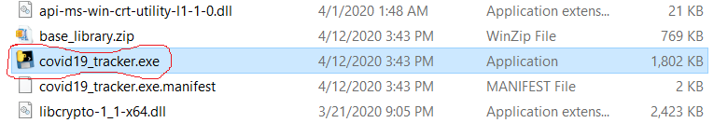

1. Below shows what is initially shown when you have double clicked the application. The text in black is the path to the executable file (which might be different in your PC).

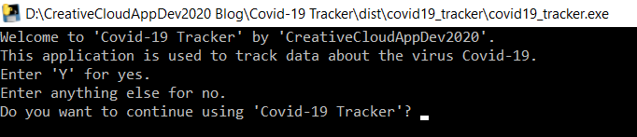

1. If you enter anything besides ‘Y’ when your asked something like in the screenshot above, you’ll quit the application.
2. If you enter ‘Y’, the application will be loading, and you need to be patient. Next, all you must do is follow the instructions (as shown in the application window and a copy of them are shown at the top of next page). Entering anything besides the allowed things to enter will make the program tell you that you gave invalid input.

Entering ‘GET GLOBAL DATA’ will make you get the latest global number of confirmed cases, deaths, and recovered cases of Covid-19. Entering 'GET DATA FOR ALL LOCATIONS' will make you get the latest number of confirmed cases, deaths, and recovered cases of Covid-19 for each location in the world.

Entering 'RANK DATA FOR ALL LOCATIONS' will ask you to choose whether you want to rank each location in the world by either the number of confirmed cases, deaths, or recovered cases of Covid-19.

Entering 'GET LOCATION BY COUNTRY CODE' will ask you to enter the country code of the location where you want to see the latest number of confirmed cases, deaths, and recovered cases of Covid-19. For example, entering “US” as the country code will get you the latest number of confirmed cases, deaths, and recovered cases of Covid-19 in the US.

Entering 'GET LOCATION BY ID’ will ask you to enter the ID of the location where you want to see the latest number of confirmed cases, deaths, and recovered cases of Covid-19. For example, entering the integer ‘39’ as the ID will get you the latest number of confirmed cases, deaths, and recovered cases of Covid-19 in Canada.

Enter 'GET GLOBAL DATA' to get latest global data about Covid-19.

Enter 'GET DATA FOR ALL LOCATIONS' to get data about Covid-19 for each location in the world.

Enter 'RANK DATA FOR ALL LOCATIONS' to rank the data about Covid-19 for each location in the world by either 'confirmed', 'deaths', or 'recovered'.

Enter 'GET LOCATION BY COUNTRY CODE' to get data about Covid-19 for a particular location in the world by keying in the country code (e.g. country code 'US' for the country US).

Enter 'GET LOCATION BY ID' to get data about Covid-19 for a particular location in the world by keying in the ID of the country (ID can range from 0 - 263).

1. Once you have completed any of the 5 actions above, you will be asked whether you want to continue using the application or not. Entering ‘Y’ will get you asked to input what you want to do with the application. Entering anything besides ‘Y’ will exit the application.